1. Intro
This documentation describes the architecture and structure of the Taxi Livo web application. The purpose of this document is to provide insight into the application's technical structure, the architecture used, and the way the different components of the application interact with one another.
In addition, this documentation serves as a reference for developers, administrators, and other stakeholders who need to understand, maintain, or further develop the application. It covers the overall architecture, the technologies used, the project structure, and the key components that make up the web application.
By clearly documenting the application's structure and design decisions, it becomes easier to add new functionality, implement changes, and ensure the quality, maintainability, and long-term sustainability of the Taxi Livo web application.

2. Project Structure
The Taxi Livo web application is built using React as its frontend framework. The application uses JavaScript (JSX) for its logic, HTML (through JSX) for its structure, and CSS for its styling. The backend is powered by Supabase, which is responsible for the database, authentication, and API functionality. The application is built and bundled using Vite, providing fast development and efficient build performance.
The project is organized according to the following structure:

taxi-app-1.0/
│
├── .vscode/
├── dist/
├── docs/
├── node_modules/
├── public/
├── src/
│ ├── assets/
│ ├── components/
│ ├── utils/
│ ├── App.jsx
│ ├── index.css
│ ├── main.jsx
│ └── supabase.js
│
├── supabase/
├── .env
├── .gitignore
├── deno.lock
├── eslint.config.js
├── generate-icons.js
├── index.html
├── package.json
├── package-lock.json
├── README.md
├── verify-supabase.js
└── vite.config.js

Explanation of Each Directory
.vscode
Contains settings specific to Visual Studio Code, such as recommended extensions and workspace configuration. This directory does not affect the functionality of the web application.

dist
Contains the compiled production build of the application. When the project is built using Vite (npm run build), all generated files are placed here. This directory is used for deployment to a web server.

docs
Contains all technical project documentation, including the architecture, installation guides, and application documentation.

node_modules
Contains all external packages and dependencies installed via npm. This directory is generated automatically and should not be modified manually.

public
Contains static files that are served directly to the browser, such as images, favicon files, and other assets that are not processed by React.

The src Directory
The src directory contains the complete source code of the React application.

assets
Contains images, icons, logos, and other static assets used throughout the application.

components
This directory contains all React components that make up the user interface. Organizing the application into components keeps the code modular, reusable, and easy to maintain.

ActionDialog
Responsible for displaying confirmation dialogs or actions that require user confirmation.

Files:
ActionDialog.jsx
ActionDialog.css
Login

Contains the application's login screen. Drivers and other users authenticate through Supabase Authentication.

Files:
Login.jsx
Login.css
MyTripLogs

Displays an overview of a driver's trip records. Users can view detailed trip information from this component.

Files:
MyTripLogs.jsx
MyTripLogs.css
Navigation

Contains the application's navigation, such as the menu or navigation bar used to switch between different screens.

Files:
Navigation.jsx
Navigation.css
RittenstaatForm

One of the core components of the application. It allows users to enter and process trip information before it is stored in Supabase.

Files:
RittenstaatForm.jsx
RittenstaatForm.css
SignatureDialog

Provides functionality for capturing a digital signature when a trip is completed or confirmed.

Files:
SignatureDialog.jsx
SignatureDialog.css
utils

Contains utility functions that are used throughout the application. Centralizing these helper functions prevents code duplication and improves maintainability.

App.jsx
The main component of the React application. It combines the various components and determines which parts of the application are displayed.

main.jsx
The entry point of the React application. It initializes React, mounts the application to the HTML document, and loads App.jsx.

index.css
Contains the global styles that apply to the entire application.

supabase.js
Contains the configuration for connecting to Supabase. It initializes the Supabase client, allowing the application to communicate with the database and authentication services.

Other Files
supabase/

Contains Supabase-related configuration files, as well as any Edge Functions or database migrations associated with the project.

.env
Contains environment variables, such as:

Supabase URL
Supabase API Key

Sensitive information is kept outside the source code by storing it in this file.

.gitignore
Specifies which files and directories should not be tracked by Git, including:

node_modules
.env
dist
eslint.config.js

Configuration file for ESLint. This tool checks the JavaScript code for potential errors and enforces a consistent coding style.

generate-icons.js
A script used to automatically generate or process application icons.

index.html
The HTML page that loads the React application. React then takes control of rendering the application's content.

package.json
Contains the project's metadata, dependencies, and available scripts, including:

npm install
npm run dev
npm run build
package-lock.json

Locks the exact versions of all installed npm packages, ensuring that every developer uses the same dependency versions.

README.md
Contains general project documentation, including installation instructions and information for developers.

verify-supabase.js
A script used to verify that the connection to Supabase is functioning correctly.

vite.config.js
The configuration file for Vite. It manages settings for the development server, build process, and any plugins used by the application.

2. Authentication

This chapter briefly describes how the login and password recovery functionality is implemented using Supabase. It serves as a reference for future developers.
Supabase Configuration (src/supabase.js)
The Supabase client is initialized using createClient from @supabase/supabase-js. The required credentials (VITE_SUPABASE_URL and VITE_SUPABASE_PUBLISHABLE_KEY) are loaded from the .env environment variables.
User Login (src/App.jsx & src/components/Login.jsx)
- UI Component: Login.jsx contains all authentication-related forms (login, forgot password, and password reset) and manages its own state to determine which view is displayed.
- Authentication Logic: The actual login functionality is implemented in App.jsx through the handleLogin function, which uses the Supabase SDK:
supabase.auth.signInWithPassword({ email, password })
- Session Management: App.jsx listens for authentication events using supabase.auth.onAuthStateChange. After a successful login, the active session is detected, the isLoggedIn state is set to true, and the session state is stored in localStorage (taxilivo_auth) to persist authentication across page reloads.
Forgot Password (Requesting a Reset Link) (src/components/Login.jsx)
- In the Forgot Password view, the user enters their email address.
- The handleForgotPasswordRequest function in Login.jsx calls:
supabase.auth.resetPasswordForEmail(email)
- Supabase handles sending the secure password reset email based on the authentication settings configured in the Supabase project dashboard.

Password Reset (src/components/Login.jsx & src/App.jsx)
- Detecting the Reset Link: When the user clicks the password reset link in the email and returns to the application, App.jsx detects the recovery flow either through the URL recovery token or the PASSWORD_RECOVERY authentication event emitted by Supabase.
- The isRecovering state is set to true, causing Login.jsx to immediately display the update_password view.
- Saving the New Password: The handlePasswordUpdateSubmit function in Login.jsx updates the user's password by calling:
supabase.auth.updateUser({ password: newPassword })
- Completion: After the password has been successfully updated, the handlePasswordUpdatedComplete callback in App.jsx is executed. As a security measure, the user is immediately signed out using supabase.auth.signOut(), after which they are required to log in again using their new password.
Error Handling
Specific Supabase error messages (such as rate limits, invalid login credentials, or network errors) are caught in Login.jsx using try...catch blocks. These errors are translated into clear, user-friendly Dutch error messages before being displayed to the user.

3. Trip Logs Architecture and Data Flow

This document describes the architecture and data flow of the Trip Logs (including Delivery Notes) from data entry on the home page through storage and display on the My Trip Logs page.
Home Page (src/components/RittenstaatForm.jsx)
The home page is implemented as the RittenstaatForm component. This is where drivers enter their trip logs and delivery notes.
- State Management: The form manages several local state variables:
  - headerLeft & headerRight: General information such as vehicle registration, date, driver name, and odometer readings.
  - trips: An array containing the standard 17 trip entries.
  - pakbonnen: A dynamic array of delivery notes. Drivers can add new delivery notes using addPakbon and remove existing ones.
  - signature: The driver's signature, stored as a Data URL and captured through a separate SignatureDialog component.
- Auto-Save (Draft): Whenever a form field or delivery note is modified, a useEffect hook triggers the onFormChange function. This callback, provided by App.jsx, immediately stores the current form data in localStorage under the key taxilivo_draft. This ensures that drivers do not lose their work if the application is closed unexpectedly.
Saving and Synchronization (src/App.jsx)
The Save and Submit actions initiated from RittenstaatForm are handled by App.jsx, which acts as the bridge between the user interface and the Supabase backend.
- Local Storage: When a trip log is saved (handleSaveLog), it is first added to the local React state (logs). This provides immediate feedback to the user (e.g., "Trip log saved locally").
- Cloud Synchronization: After the local save, the application synchronizes the data with Supabase in the background:
  - The parent form object is converted using mapStateToDbForm and written to the forms table using .upsert().
  - Associated delivery notes are linked to the corresponding form_id and stored in the pakbonnen table using .upsert().
  - Delivery notes that have been removed locally are automatically deleted from Supabase using .delete() to keep the database synchronized.
- Submitting a Trip Log: When the user clicks Submit, or when handleSendLog is called, the application first generates a PDF and sends it via the Supabase Edge Function send-email. If the operation succeeds, the trip log status is updated to 'submitted', the corresponding record in Supabase is updated, and the local draft is removed from storage.
My Trip Logs (src/components/MyTripLogs.jsx)
This component is responsible for displaying the driver's trip log history. The data (logs) is retrieved by App.jsx from Supabase when the user logs in, using a relational query that loads records from the forms table together with their associated pakbonnen.
- Display and Sorting: Trip logs are sorted chronologically (sortedLogs) and displayed as individual log cards.
- Information and Status: Each card displays key information, including:
  - Date
  - Driver
  - Vehicle
  - Status badge (Saved or Submitted)
  - Delivery note indicator (e.g., Delivery Notes (2))
- Available Actions for Each Trip Log:
  - Open/Edit: Reloads the selected trip log into RittenstaatForm as a draft, provided its status is still saved.
  - Submit: Users can submit a previously saved trip log directly from this overview using the Submit button (onSubmit). This sends the email and updates the status to submitted.
  - Delete: Removes the trip log using handleDeleteLog. The log is removed immediately from the local interface and then permanently deleted from Supabase in the background.
- Bulk Actions: Users can select multiple trip logs using checkboxes and perform batch operations, such as downloading them as a single merged PDF or deleting multiple logs simultaneously using handleDeleteLogs.

4. Trip Log Submission Flow (Supabase)

This section describes the workflow that is executed when a driver chooses to permanently submit a trip log (with or without associated delivery notes). The architecture is designed to perform server-side operations, such as sending emails, securely through Supabase Edge Functions.
What Happens When the User Clicks Submit?
The submission logic is primarily implemented in the submitTripLog() function and its related handlers in src/App.jsx.
- Local PDF Generation
Before communicating with the server, the application uses generatePdfBlob(logData) (from src/utils/pdfGenerator.js) to generate a binary PDF Blob containing the trip log and any associated delivery notes directly in the browser.
- Building the Payload
To minimize overhead (such as Base64 encoding), the generated PDF is combined with metadata—including the vehicle number, driver name, and date—into a native FormData object.
- Invoking the Supabase Edge Function
The application calls:
supabase.functions.invoke('send-email', { body: formData })
This invokes the secure send-email Edge Function hosted on the Supabase server.
- Server-Side Processing with Resend
The Edge Function extracts the PDF from the FormData object and sends it using Resend, which is responsible for the reliable delivery of the email and its PDF attachment to the central office.
- Database Synchronization
Only after the email has been sent successfully is the trip log status updated to 'submitted' in the React application. The application then performs an .upsert() to the Supabase database, permanently storing the trip log with submitted_at = now(). Finally, the local draft cache (taxilivo_draft in localStorage) is removed to complete the submission process.
Visual Representation (Data Flow)
The following Mermaid sequence diagram illustrates the flow of data during the submission process.

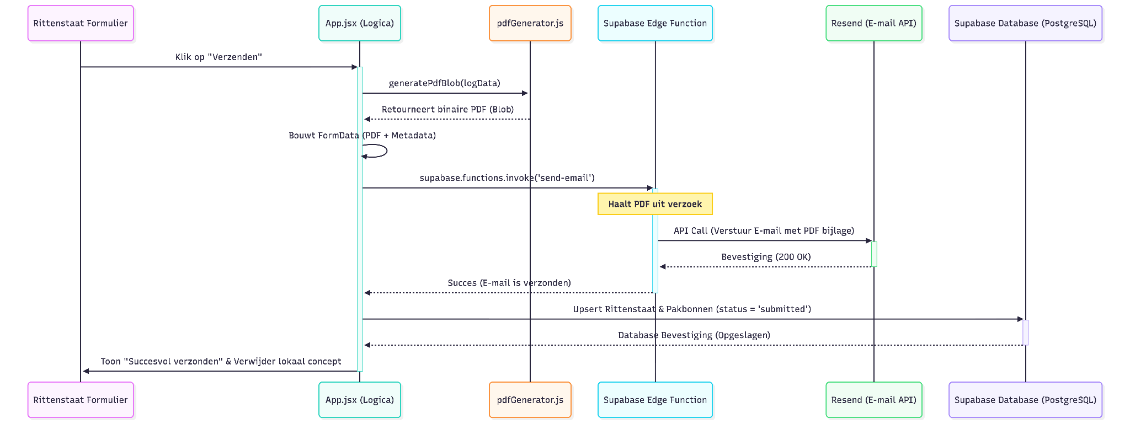
```mermaid
sequenceDiagram
participant UI as Rittenstaat Formulier
participant App as App.jsx (Logica)
participant PDF as pdfGenerator.js
participant Edge as Supabase Edge Function
participant Resend as Resend (E-mail API)
participant DB as Supabase Database (PostgreSQL)

UI->>App: Klik op "Verzenden"
activate App
App->>PDF: generatePdfBlob(logData)
PDF-->>App: Retourneert binaire PDF (Blob)

App->>App: Bouwt FormData (PDF + Metadata)

App->>Edge: supabase.functions.invoke('send-email')
activate Edge
Note over Edge: Haalt PDF uit verzoek
Edge->>Resend: API Call (Verstuur E-mail met PDF bijlage)
activate Resend
Resend-->>Edge: Bevestiging (200 OK)
deactivate Resend
Edge-->>App: Succes (E-mail is verzonden)
deactivate Edge

App->>DB: Upsert Rittenstaat & Pakbonnen (status = 'submitted')
activate DB
DB-->>App: Database Bevestiging (Opgeslagen)
deactivate DB

App->>UI: Toon "Succesvol verzonden" & Verwijder lokaal concept
deactivate App
```

## 3. Flowchart
In addition to the interaction diagram above, the following flowchart illustrates the logical sequence of the submission process, including error handling.
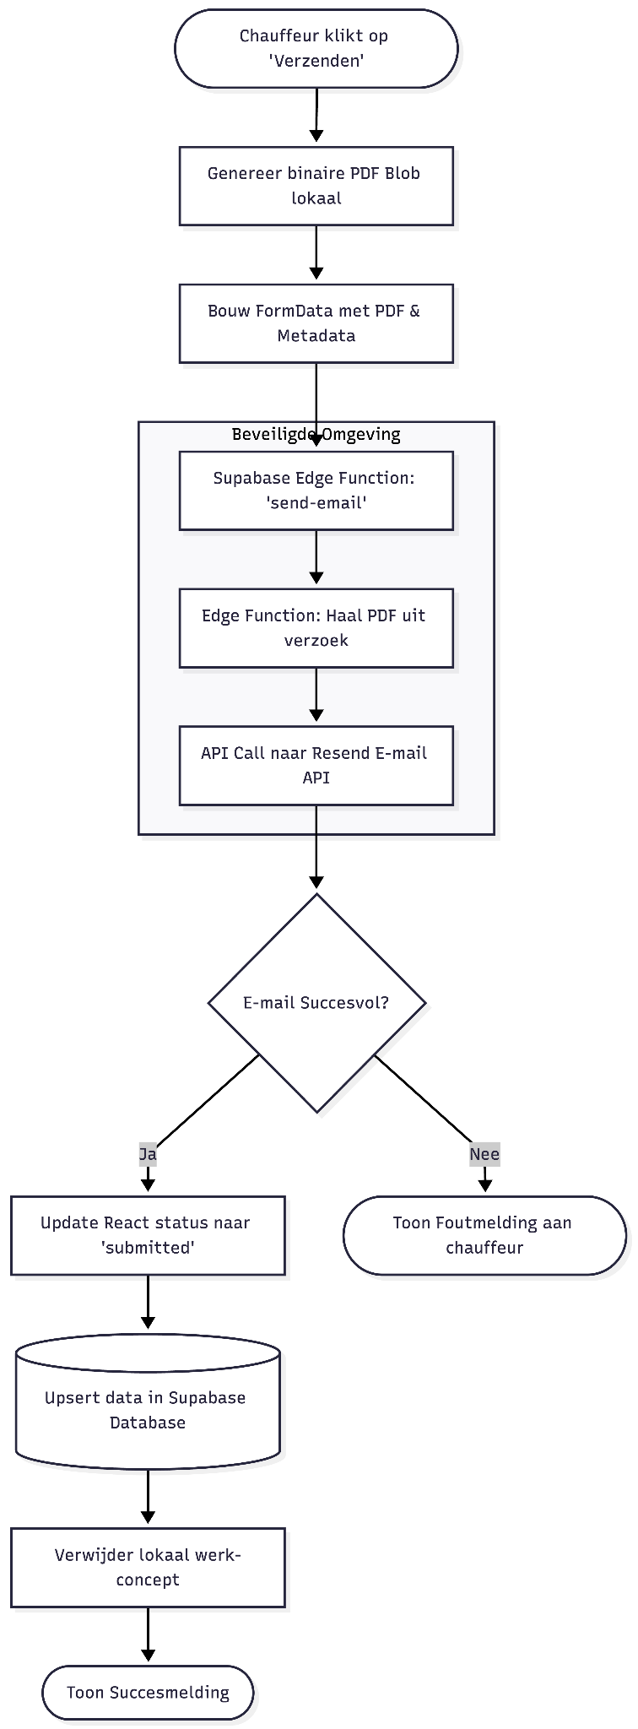
```mermaid
flowchart TD
Start([Chauffeur klikt op 'Verzenden']) --> GenPDF[Genereer binaire PDF Blob lokaal]
GenPDF --> FormData[Bouw FormData met PDF & Metadata]
FormData --> EdgeCall[Supabase Edge Function: 'send-email']

subgraph Server-Side [Beveiligde Omgeving]
EdgeCall --> Extract[Edge Function: Haal PDF uit verzoek]
Extract --> Resend[API Call naar Resend E-mail API]
end

Resend --> SuccessCheck{E-mail Succesvol?}

SuccessCheck -- Ja --> UpdateStatus[Update React status naar 'submitted']
UpdateStatus --> UpsertDB[(Upsert data in Supabase Database)]
UpsertDB --> ClearDraft[Verwijder lokaal werk-concept]
ClearDraft --> EndSuccess([Toon Succesmelding])

SuccessCheck -- Nee --> EndError([Toon Foutmelding aan chauffeur])
```

5. Database Architectuur & Connectie Overzicht
This document provides a high-level overview of the interaction between the React frontend (Web Application), the Supabase platform (API & Authentication), and the underlying PostgreSQL database. Its purpose is to give future developers a clear understanding of the complete data flow, from user authentication to storing and permanently submitting a trip log.
The Three Layers of the Architecture
Frontend (React Web Application)
The frontend runs in the user's browser and provides the application's user interface. User interactions take place here, application state is managed locally (using React state and localStorage), and PDF documents are generated before submission.
Supabase (Backend-as-a-Service)
Supabase acts as the middleware between the frontend and the database. It provides ready-to-use services, including:
- Supabase Auth for user authentication.
- PostgREST, a REST API for interacting with the PostgreSQL database.
- Edge Functions, which allow secure execution of server-side code.
PostgreSQL (Database)
PostgreSQL is the underlying relational database that powers Supabase. It stores application data in tables such as forms (trip logs) and pakbonnen (delivery notes), while user authentication data is securely managed in Supabase's protected auth.users table.
Data Flow (User Journey)
User Login
When a user opens the application and signs in, the frontend sends the user's email address and password to Supabase Auth. Supabase securely validates these credentials against the auth.users table in PostgreSQL. If authentication is successful, the frontend receives a session containing a JWT token, which authorizes the user for subsequent requests.
Loading Trip History (My Trip Logs)
After the user has successfully signed in, the application retrieves previously saved trip logs from the database. Using Supabase's relational query capabilities, a single request fetches both the forms records and their associated pakbonnen records from PostgreSQL.
Creating and Saving a Trip Log
When the user completes a trip log and/or adds delivery notes, clicking Save (or triggering the automatic local draft save) stores the data. Database synchronization is performed through the Supabase API using an .upsert() operation (update or insert). The data is then written directly to the public.forms and public.pakbonnen tables in PostgreSQL.
Submitting a Trip Log
Once the trip log is complete and the user clicks Submit, the process follows a secure server-side workflow to enable email delivery. The application first generates a PDF locally in the browser and sends it to a Supabase Edge Function. After the Edge Function successfully delivers the email using Resend, the application performs one final update through the Supabase API, marking the corresponding database record in PostgreSQL with the status 'submitted'.

## Flowchart

The diagram below illustrates the complete lifecycle of the application's data, clearly showing the separation between the Supabase platform (its APIs and backend services) and the underlying PostgreSQL database.

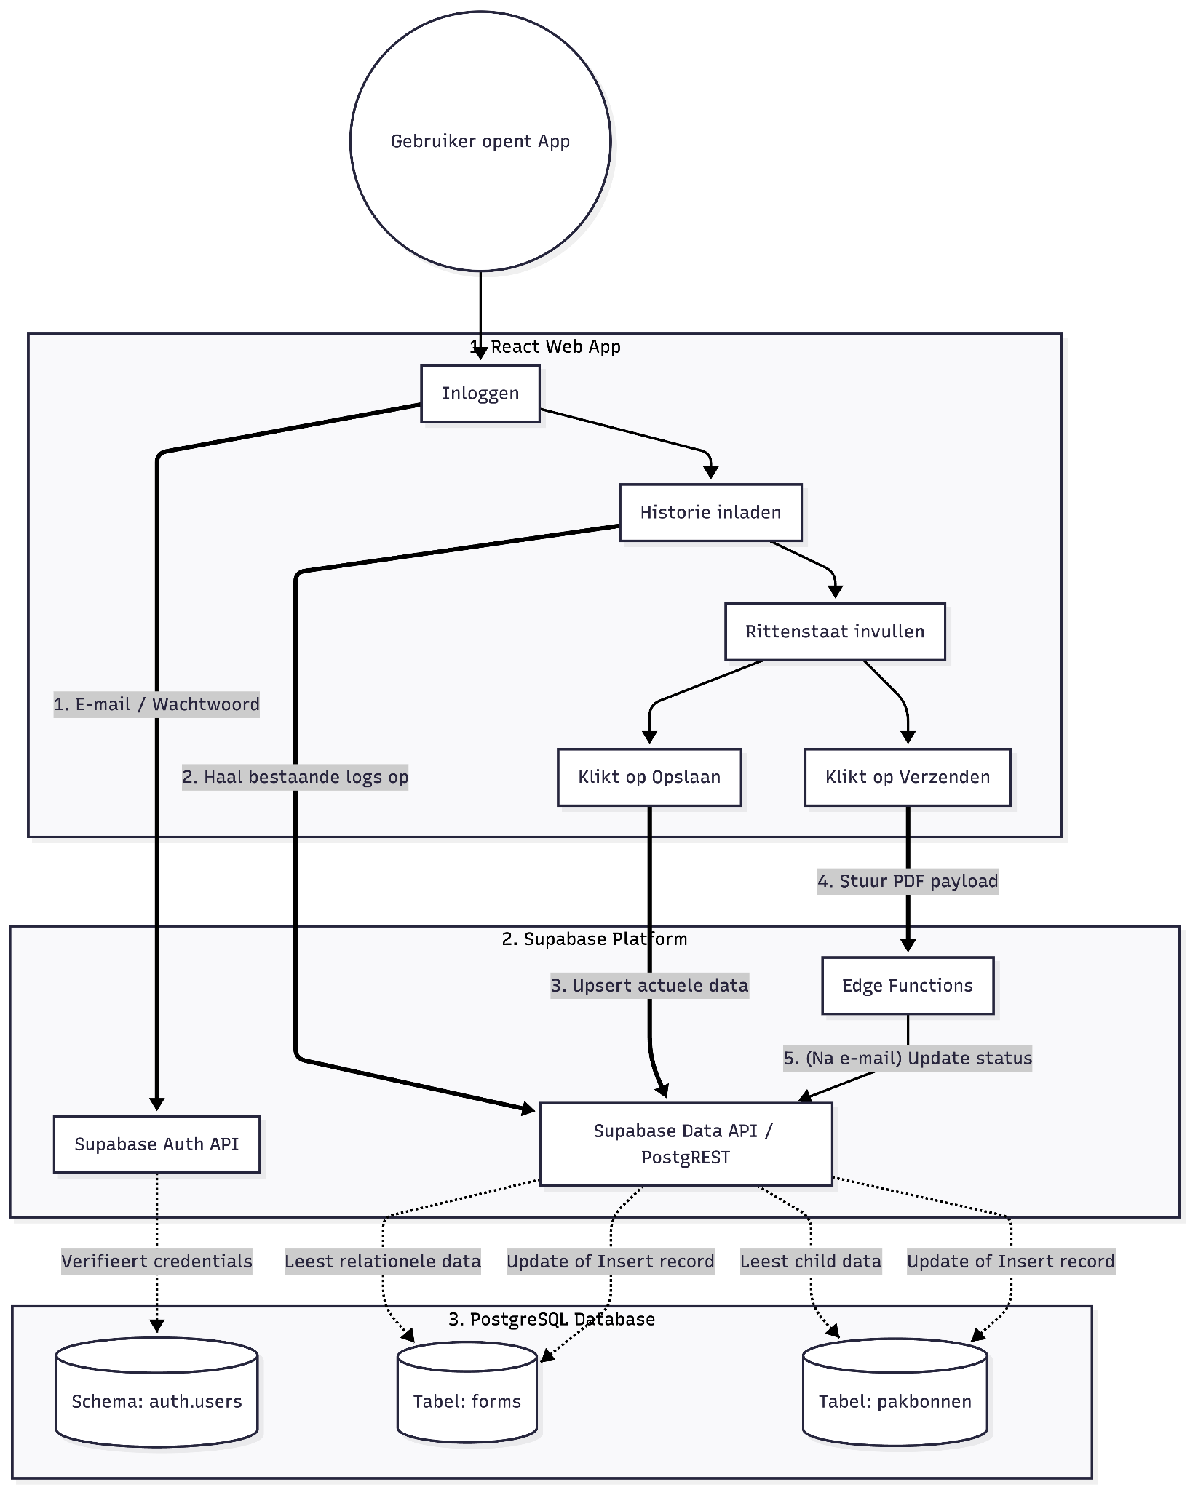

```mermaid
flowchart TD
%% Gebruiker / Start
Start((Gebruiker opent App)) --> Login

%% Frontend Laag
subgraph Frontend [1. React Web App]
Login[Inloggen]
Overzicht[Historie inladen]
VulIn[Rittenstaat invullen]
Opslaan[Klikt op Opslaan]
Verzenden[Klikt op Verzenden]

Login --> Overzicht
Overzicht --> VulIn
VulIn --> Opslaan
VulIn --> Verzenden
end

%% Supabase API Laag
subgraph Supabase [2. Supabase Platform]
AuthAPI[Supabase Auth API]
RestAPI[Supabase Data API / PostgREST]
Edge[Edge Functions]
end

%% PostgreSQL Database Laag
subgraph Database [3. PostgreSQL Database]
DB_Users[(Schema: auth.users)]
DB_Forms[(Tabel: forms)]
DB_Pakbonnen[(Tabel: pakbonnen)]
end

%% Connecties Inloggen
Login == "1. E-mail / Wachtwoord" ==> AuthAPI
AuthAPI -. "Verifieert credentials" .-> DB_Users

%% Connecties Historie Inladen
Overzicht == "2. Haal bestaande logs op" ==> RestAPI
RestAPI -. "Leest relationele data" .-> DB_Forms
RestAPI -. "Leest child data" .-> DB_Pakbonnen

%% Connecties Opslaan
Opslaan == "3. Upsert actuele data" ==> RestAPI
RestAPI -. "Update of Insert record" .-> DB_Forms
RestAPI -. "Update of Insert record" .-> DB_Pakbonnen

%% Connecties Verzenden
Verzenden == "4. Stuur PDF payload" ==> Edge
Edge -- "5. (Na e-mail) Update status" --> RestAPI
```

6. Database
This chapter describes the database schema of the Taxi Livo web application. The application uses a PostgreSQL database managed by Supabase. The database is designed to store trip logs, delivery notes, and user information in a structured, reliable, and secure manner.
The schema consists of three main tables: auth.users, forms, and pakbonnen. The auth.users table contains information about authenticated users, while the forms table stores trip logs and the pakbonnen table stores the associated delivery note records.
These tables are linked through primary and foreign key relationships, ensuring data integrity and maintaining the relationships between users, trip logs, and their corresponding delivery notes.

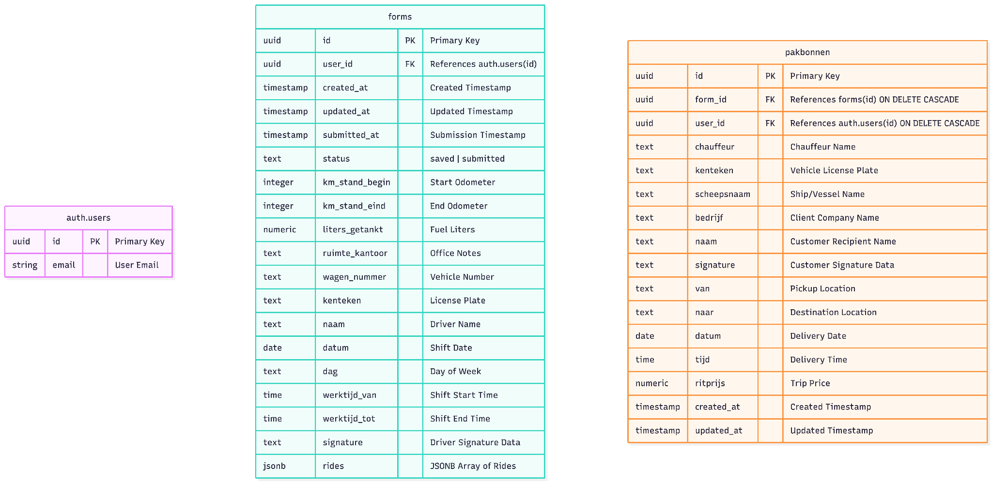

erDiagram
"auth.users" {
uuid id PK "Primary Key"
string email "User Email"
}
forms {
uuid id PK "Primary Key"
uuid user_id FK "References auth.users(id)"
timestamp created_at "Created Timestamp"
timestamp updated_at "Updated Timestamp"
timestamp submitted_at "Submission Timestamp"
text status "saved | submitted"
integer km_stand_begin "Start Odometer"
integer km_stand_eind "End Odometer"
numeric liters_getankt "Fuel Liters"
text ruimte_kantoor "Office Notes"
text wagen_nummer "Vehicle Number"
text kenteken "License Plate"
text naam "Driver Name"
date datum "Shift Date"
text dag "Day of Week"
time werktijd_van "Shift Start Time"
time werktijd_tot "Shift End Time"
text signature "Driver Signature Data"
jsonb rides "JSONB Array of Rides"
}
pakbonnen {
uuid id PK "Primary Key"
uuid form_id FK "References forms(id) ON DELETE CASCADE"
uuid user_id FK "References auth.users(id) ON DELETE CASCADE"
text chauffeur "Chauffeur Name"
text kenteken "Vehicle License Plate"
text scheepsnaam "Ship/Vessel Name"
text bedrijf "Client Company Name"
text naam "Customer Recipient Name"
text signature "Customer Signature Data"
text van "Pickup Location"
text naar "Destination Location"
date datum "Delivery Date"
time tijd "Delivery Time"
numeric ritprijs "Trip Price"
timestamp created_at "Created Timestamp"
timestamp updated_at "Updated Timestamp"
}

